HR Connect – Employee and Leave Management System

HRConnect Software Design Document

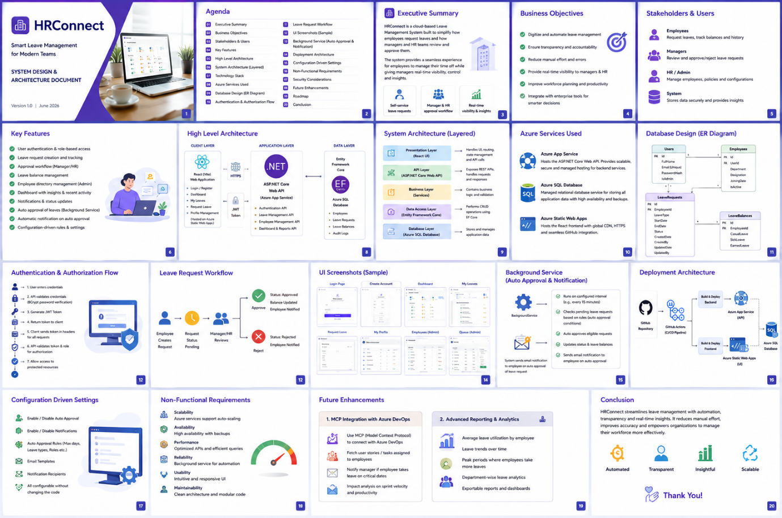

Coverage Report

